**CS 150 Introduction to CS I**

**Python – In class activity**

Write a program that prompts the user for two integers and then prints

* The sum
* The difference
* The product
* The average
* The distance (absolute value of the difference)
* The maximum (the larger of the two)
* The minimum (the smaller of the two)

Use %- formatting or str.format( ) to display output as follows:

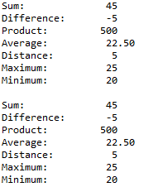

Sample Run (user input shown in bold)

----------------------------------------------------

Enter number 1: **20**

Enter number 2: **25**

